ApexPlanet Data Analytics Internship
Task 2 — Exploratory Data Analysis (EDA) & Business Intelligence
This report covers descriptive statistics, univariate and multivariate visual analysis, and seven SQL-driven business questions answered against a normalized (fact + dimension) relational model built from the Task 1 cleaned dataset (1,000 transactions).

1. Descriptive Statistics & Univariate Analysis

1.1 Numerical Summary
Field | Count | Mean | Std Dev | Min | Median | Max | Skew
Age | 1000 | 41.3 | 13.7 | 18 | 41 | 65 | 0.04
Quantity | 1000 | 5.4 | 2.8 | 1 | 5 | 10 | 0.06
Unit_Price (INR) | 1000 | 25,487 | 14,179 | 146 | 25,399 | 49,998 | -0.03
Total_Sales (INR) | 1000 | 139,399 | 114,100 | 437 | 108,594 | 493,678 | 0.99

Age, Quantity, and Unit_Price are all approximately symmetric (skew near 0), consistent with uniformly-distributed simulated ranges. Total_Sales is right-skewed (skew ≈ 0.99) because it is the product of two independent variables — a small share of orders combine both high quantity and high unit price, pulling the tail right.

1.2 Categorical Summary
Field | Unique Values | Most Common (share)
Gender | 2 | Male (51.1%)
City | 9 | Patna (13.5%)
Product | 6 | Mobile (18.4%)
Category | 5 | Electronics (35.4%)
Age_Group | 5 | 26-35 (22.3%)
Price_Tier | 4 | Premium 20K-40K (42.2%)

Electronics is the dominant category (35.4% of orders) and Mobile the top-selling individual product (18.4%). Gender is nearly balanced (51.1% Male / 48.9% Female). Premium-priced items (INR 20K–40K) make up the largest price tier at 42.2% of transactions.

1.3 Distribution Charts
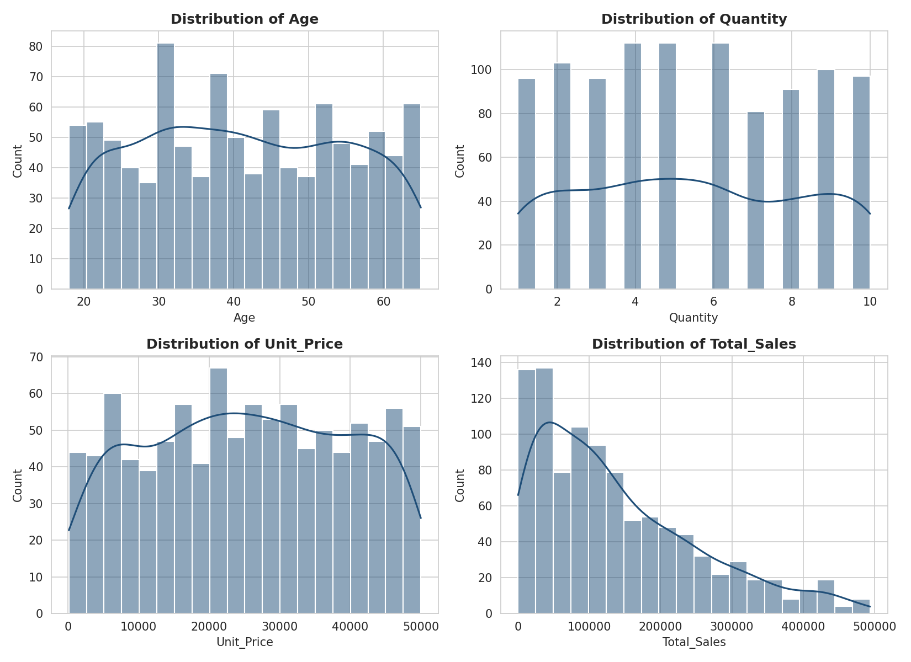
Figure 1. Distributions of Age, Quantity, Unit_Price, and Total_Sales.
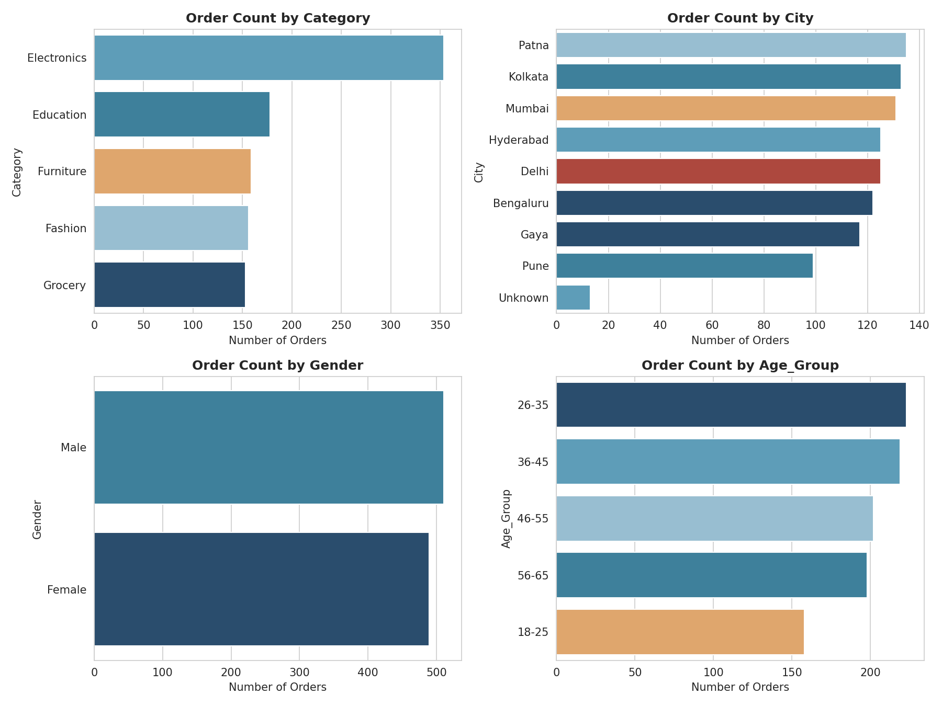
Figure 2. Order counts by Category, City, Gender, and Age Group.
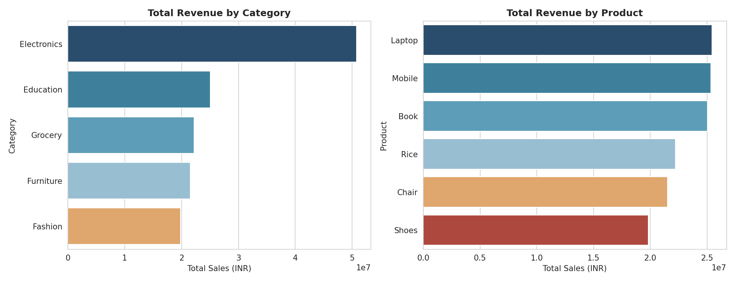
Figure 3. Total revenue by Category and by Product.

2. SQL for Business Questions
A normalized schema was built in SQLite from the cleaned dataset to practice filtering, aggregation, and multi-table joins:
- dim_customers (Customer_ID, Customer_Name, Age, Gender, City) — 947 unique customers
- dim_products (Product, Category) — 6 products across 5 categories
- fact_sales (Order_ID, Order_Date, Customer_ID, Product, Quantity, Unit_Price, Total_Sales, date parts) — 1,000 transactions
Full SQL text for all 7 queries is in sql_business_questions.sql; full result sets are in sql_query_results.xlsx. Key results below.

Q1. Top 5 products by revenue in the last 6 months of data
Product | Category | Revenue (INR) | Units Sold | Orders
Laptop | Electronics | 13,009,495 | 501 | 88
Book | Education | 12,739,833 | 542 | 92
Chair | Furniture | 11,560,952 | 467 | 87
Shoes | Fashion | 11,149,392 | 453 | 81
Rice | Grocery | 10,215,564 | 394 | 75

Q3. Which city generates the highest revenue and average order value?
City | Orders | Revenue (INR) | Avg Order Value (INR)
Kolkata | 137 | 19,932,381 | 145,492
Bengaluru | 129 | 19,345,877 | 149,968
Patna | 136 | 19,067,769 | 140,204
Mumbai | 130 | 17,819,673 | 137,074
Hyderabad | 126 | 17,391,714 | 138,029
Kolkata leads in total revenue, but Pune has the highest average order value (INR 150,256) despite fewer orders — a smaller, higher-spending customer base.

Q4. Which customer age group contributes the most revenue?
Age Group | Orders | Revenue (INR) | Avg Order Value (INR)
26-35 | 227 | 31,745,367 | 139,847
36-45 | 216 | 29,831,683 | 138,110
56-65 | 197 | 27,508,192 | 139,635
46-55 | 204 | 27,506,685 | 134,837
18-25 | 156 | 22,807,512 | 146,202
The 26-35 age group contributes the most total revenue, but the 18-25 group has the highest average order value (INR 146,202) — fewer, larger purchases.

Q7. Weekday vs. weekend sales pattern
Day Type | Orders | Revenue (INR) | Avg Order Value (INR)
Weekday | 712 | 101,028,319 | 141,894
Weekend | 288 | 38,371,120 | 133,233
Weekdays account for ~71% of orders and ~72% of revenue, roughly proportional to the 5:2 weekday/weekend day-count ratio — order value per transaction is similar across both.

3. Multivariate Analysis & Correlation

3.1 Correlation Heatmap
 | Age | Quantity | Unit_Price | Total_Sales
Age | 1.00 | -0.03 | -0.01 | 0.00
Quantity | -0.03 | 1.00 | 0.02 | 0.65
Unit_Price | -0.01 | 0.02 | 1.00 | 0.69
Total_Sales | 0.00 | 0.65 | 0.69 | 1.00

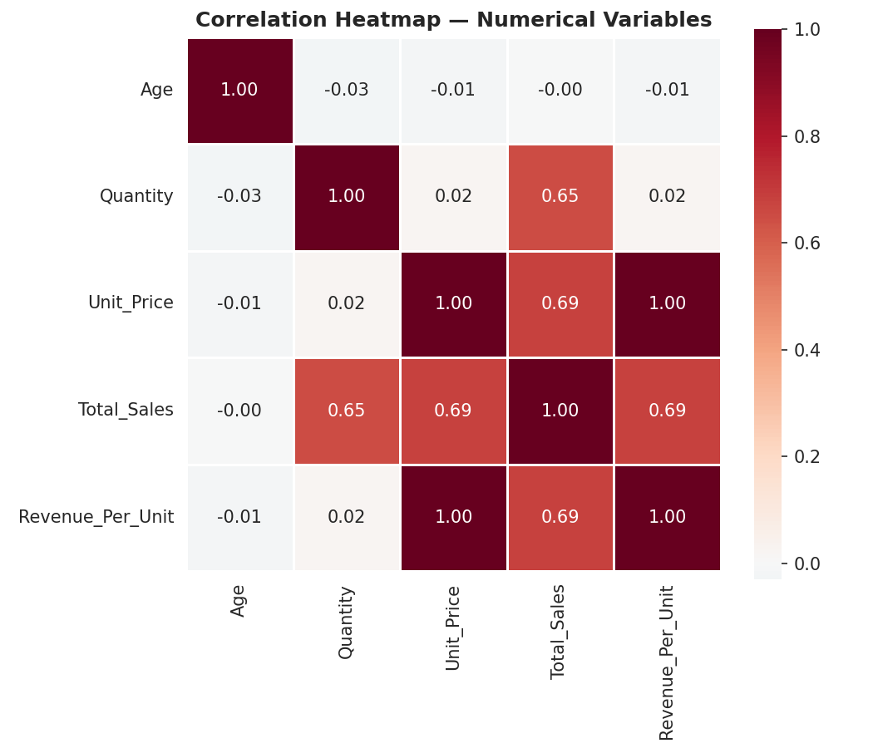
Figure 4. Correlation heatmap across numerical variables.
Total_Sales correlates moderately with both Quantity (r=0.65) and Unit_Price (r=0.69) — expected, since it is their product. Age shows essentially no linear relationship with any purchasing variable (|r| < 0.03), meaning age alone is a weak predictor of spend in this dataset.

3.2 Age vs. Total Sales, by Category
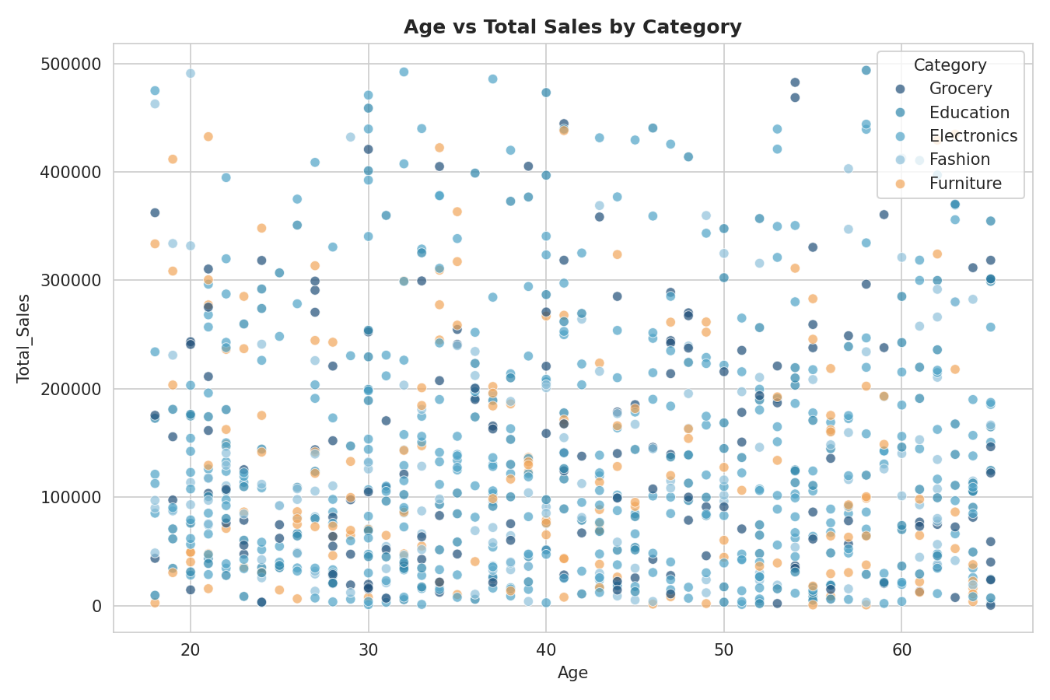
Figure 5. Age vs Total Sales, colored by Category — no visible age-based clustering.

3.3 Unit Price vs. Quantity
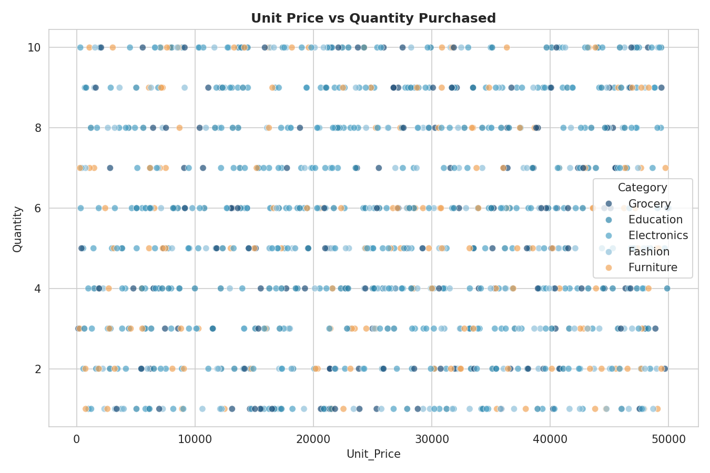
Figure 6. Unit Price vs Quantity — confirms these two drivers of revenue are uncorrelated with each other.

3.4 Age Distribution by Product Category
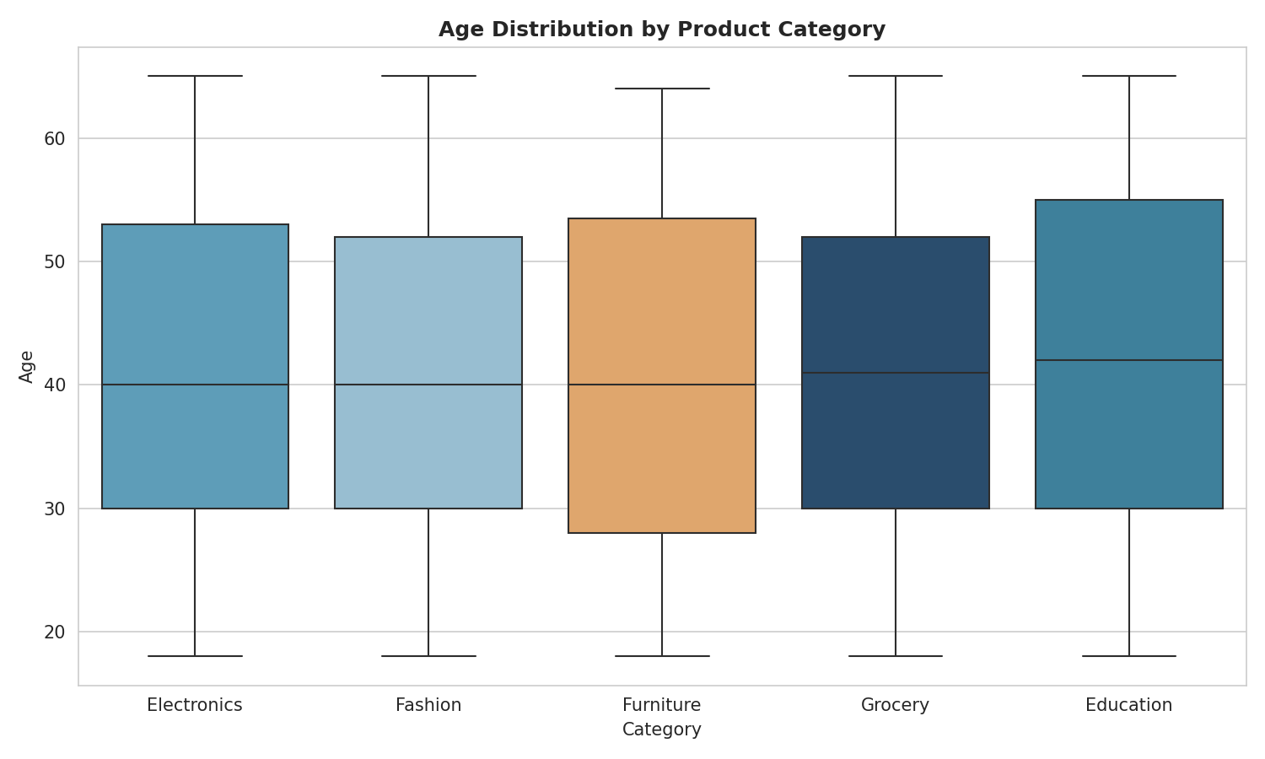
Figure 7. Age spread is similar across all categories — no category skews toward a particular age group.

3.5 Pair Plot
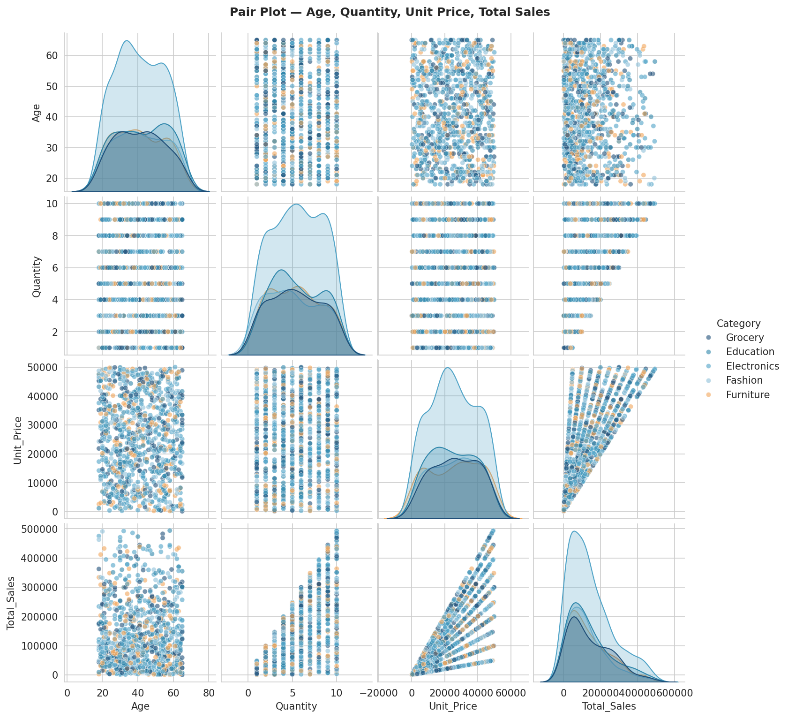
Figure 8. Pairwise relationships between Age, Quantity, Unit Price, and Total Sales, by Category.

3.6 Monthly Revenue Trend
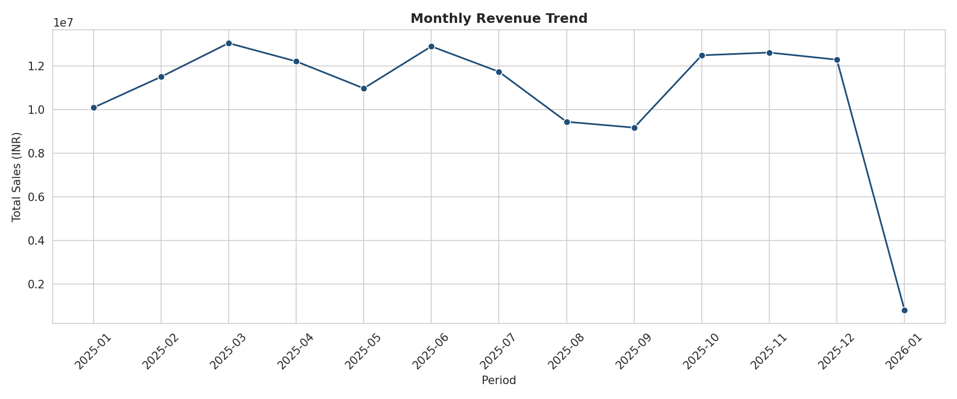
Figure 9. Monthly revenue is fairly stable (~INR 9-13M/month) with no strong seasonal pattern in this sample.

4. Key Takeaways
- Electronics (led by Mobile and Laptop) is the strongest category by both order volume and revenue.
- Total_Sales is driven jointly by Quantity and Unit_Price (each r ≈ 0.65-0.69); neither Age nor Gender meaningfully predicts spend on their own.
- Kolkata, Bengaluru, and Patna are the top three cities by revenue; Pune stands out for the highest average order value.
- The 26-35 age group is the single largest revenue contributor; the 18-25 group spends the most per order on average.
- Sales are steady month-to-month with no dramatic seasonality, and weekday/weekend performance is proportional to the number of days in each.

